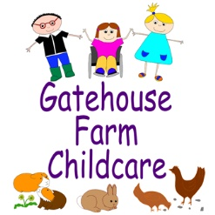
Working in Partnership with Parents Policy at Gatehouse Farm Childcare

It is very important for your child that we work in partnership. This will give your child continuity of care and (s)he will not become confused with different standards of behaviour and boundaries.
As parents you are the central adults in your child's life and the ones making decisions on their behalf. Gatehouse Farm Childcare will endeavour to work closely with you in order to carry out your wishes for your child wherever I can. It is, therefore, important that we have an excellent communication system.
Gatehouse Farm Childcare appreciate that as a working parent you will be in a rush to go to work in the mornings and in the evenings you may well be tired and need to go as quickly as possible, so we use the Baby’s Days system for additional communication with you, you will be able to read your child’s diaries, view photographs and more on the system.
Keyworkers will update Baby’s Days regularly with achievements your child has achieved. You can also do this if you feel your child is secure in an area of development.
Gatehouse Farm Childcare would also appreciate it if you could inform us if there are any changes to contact numbers for yourselves, including work and mobile numbers and those of your emergency contacts.
As your child grows and develops issues will crop up that are very important for us to discuss in order that we can work together and your wishes be incorporated into our care routine for your child. These could include weaning, potting training, managing behaviour, starting school etc.
If you wish Gatehouse Farm Childcare to incorporate a special activity into our routine, perhaps a festival or religious holiday that you celebrate please let me know.
If Gatehouse Farm Childcare have any concerns about your child's behaviour, development, eating etc we will share them with you and if necessary work with you to seek support from outside agencies.
Claire Mildenhall
Manager at Gatehouse Farm Childcare

